Isaiah Narisma

Professor Underhill

MIS 484-6 (01) 42896

14 December, 2020

GCP Automation Cloud Deployment

At this point, I had just moved over to GCP because I had initially started the project in AWS. I figured that all I had to do was provision an instance and reconnect my github repository and perform a `git clone` to get all my resources back.

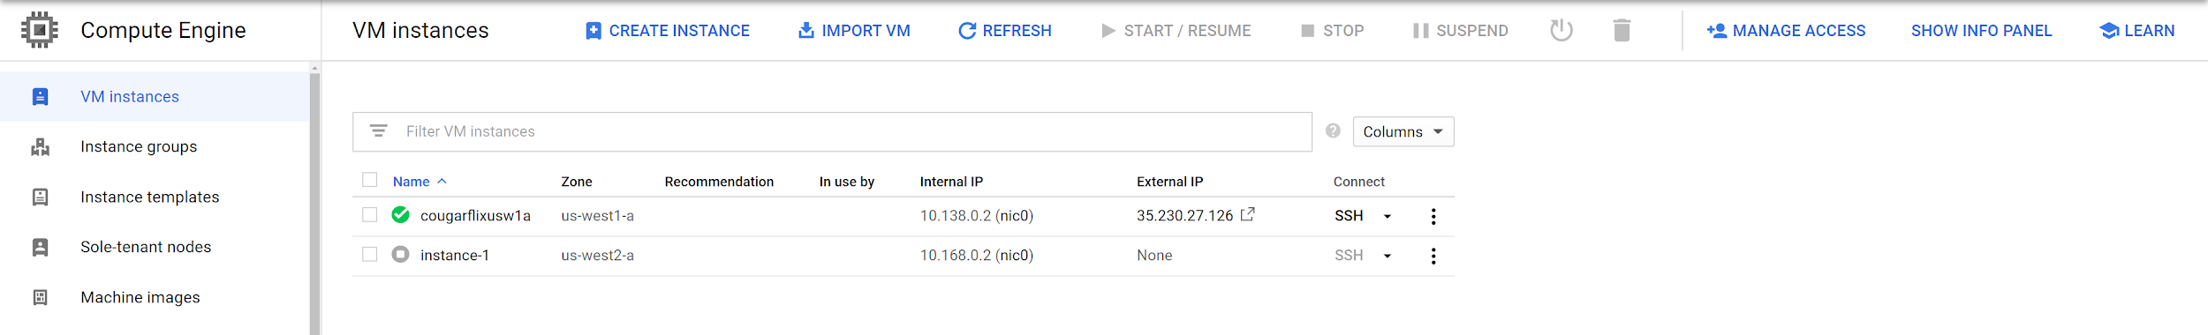

Creating the first instance `cougarflixusw1a` to install homebrew, vault, terraform, and to administer all overhead activities.

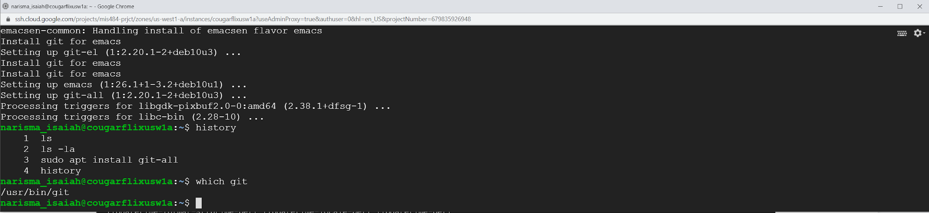

Installing Git to connect to GitHub

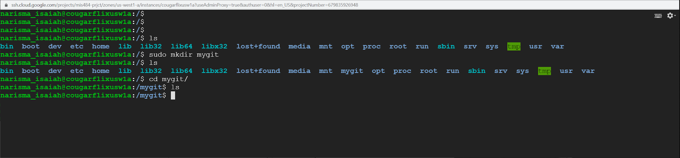

Creating the `mygit` directory to link my github repo

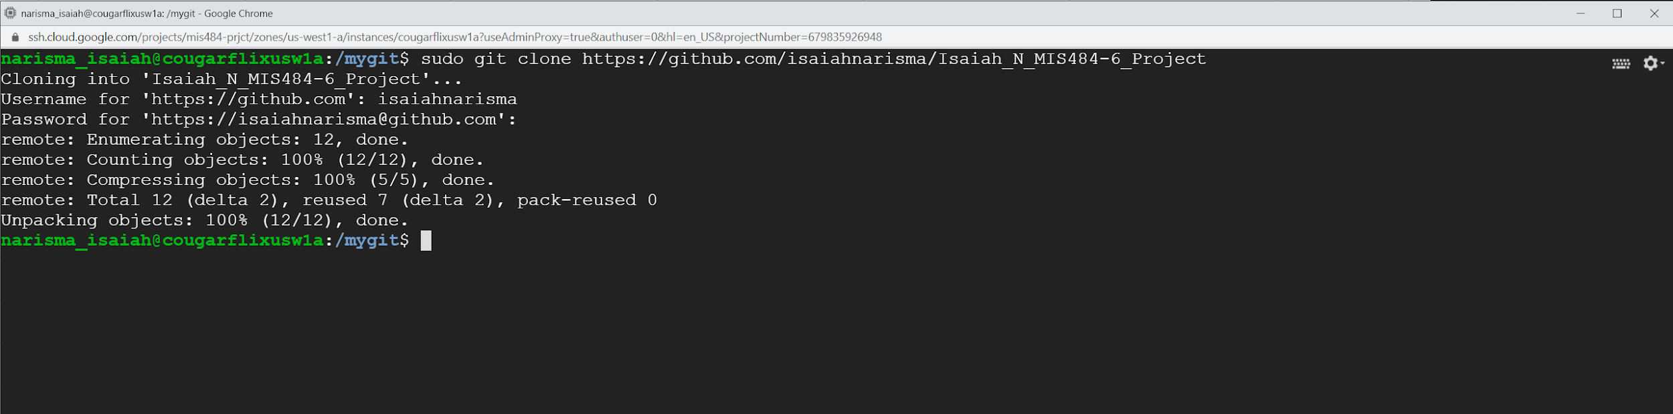

Cloning the `Isaiah_N_MIS484-6_Project` *changed to /mis484finalproject in final repo* repo from github

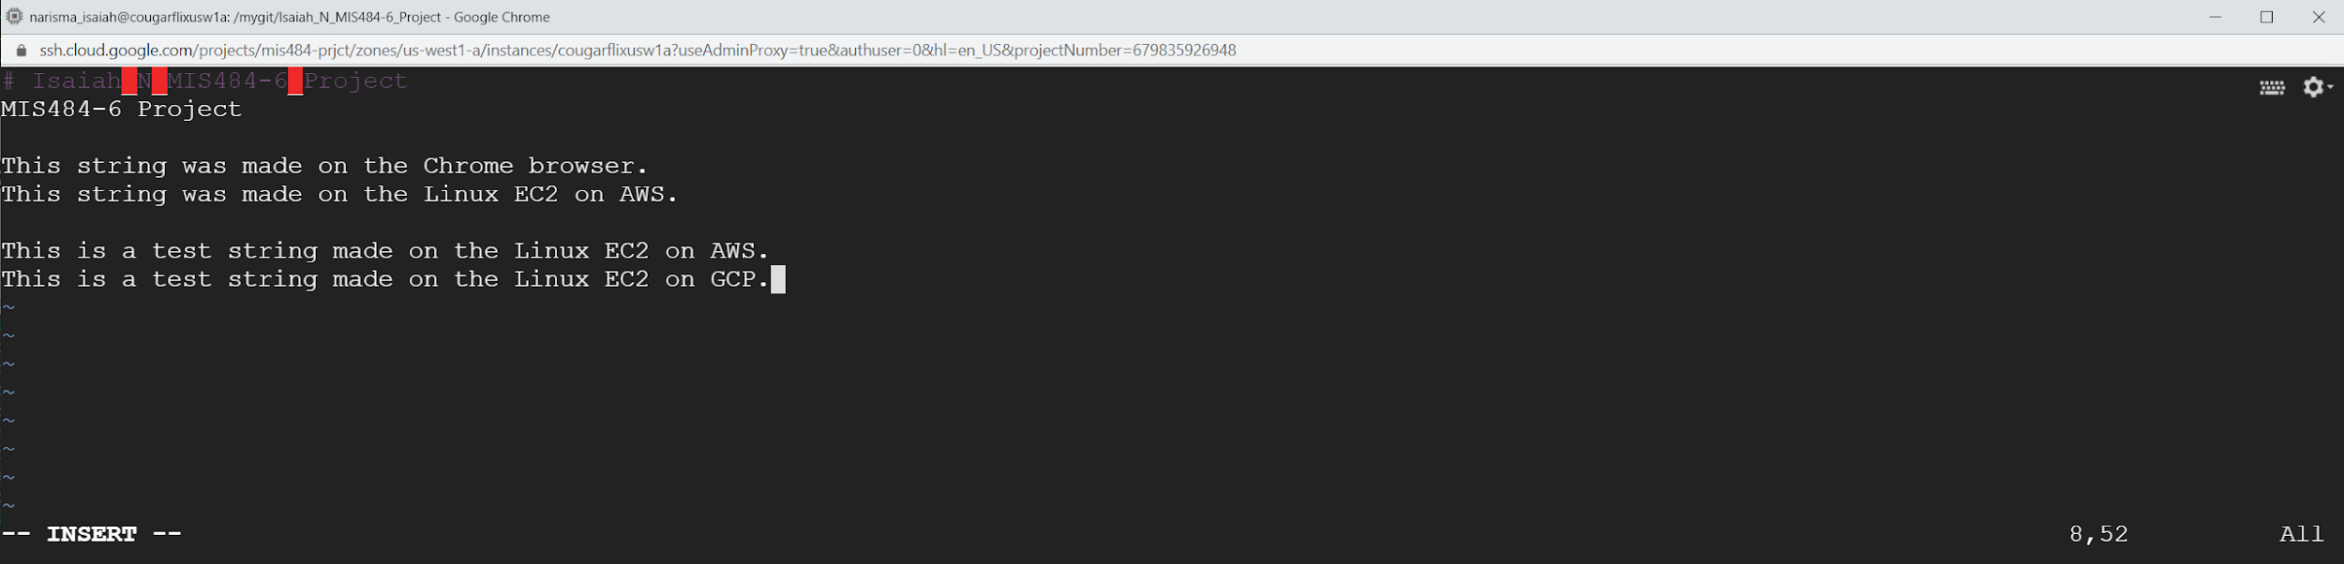

Checking my vim text `README` file and updating it with a GCP test string.

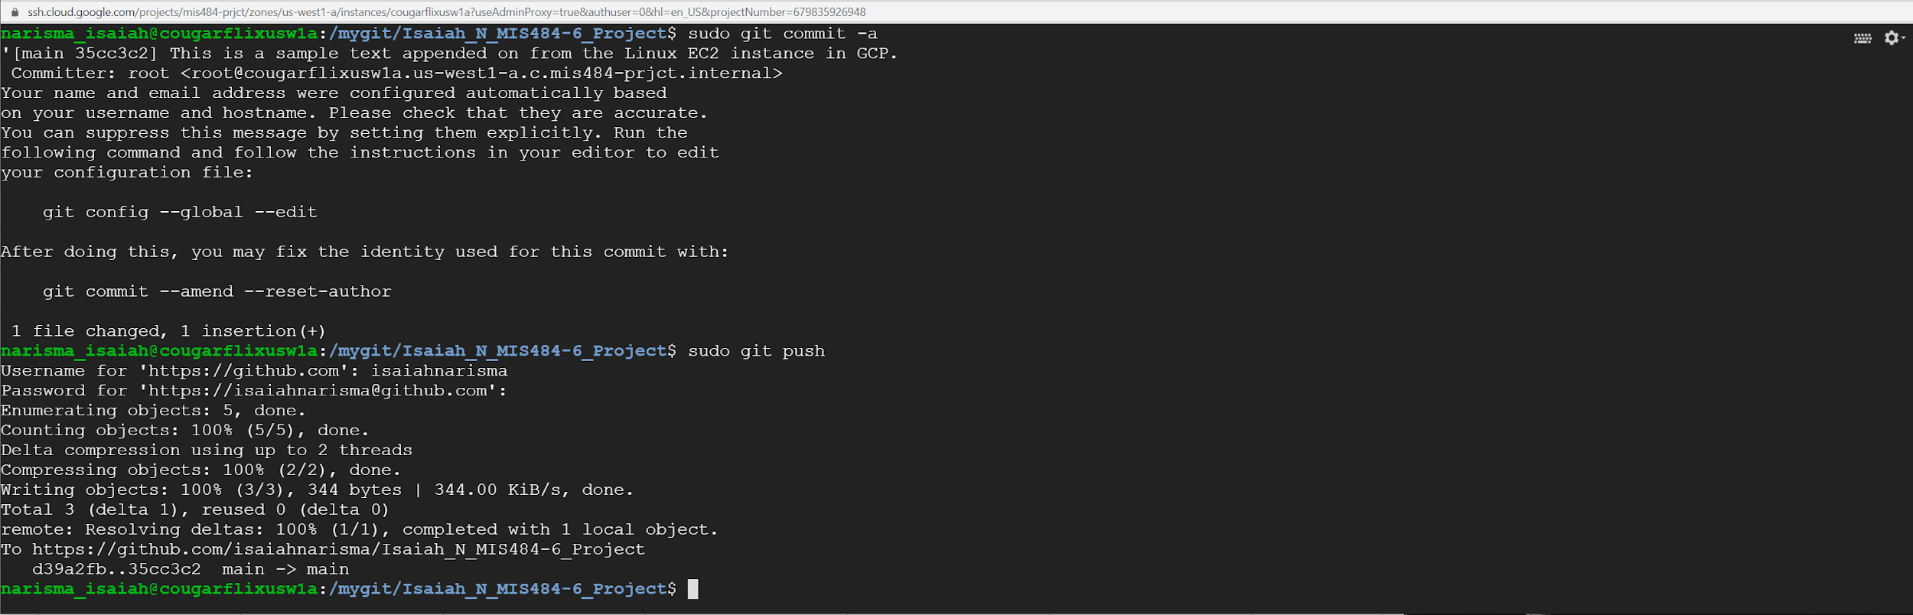

Committing a change in git

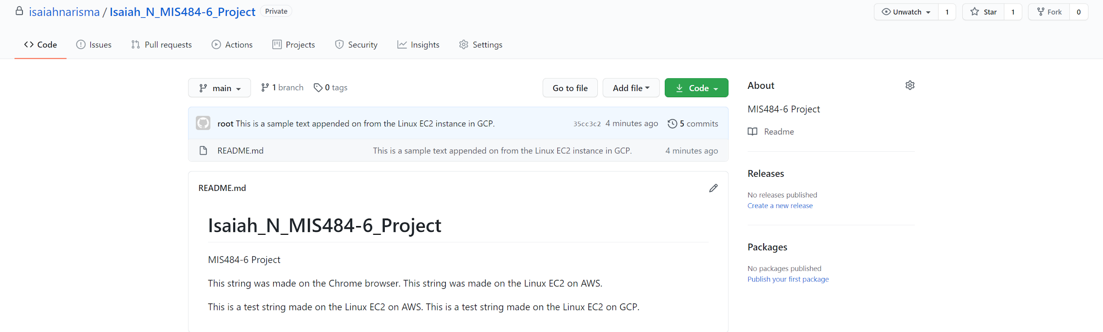

Confirmation of change made in Linux appears on the github repository and can be viewed in the browser.

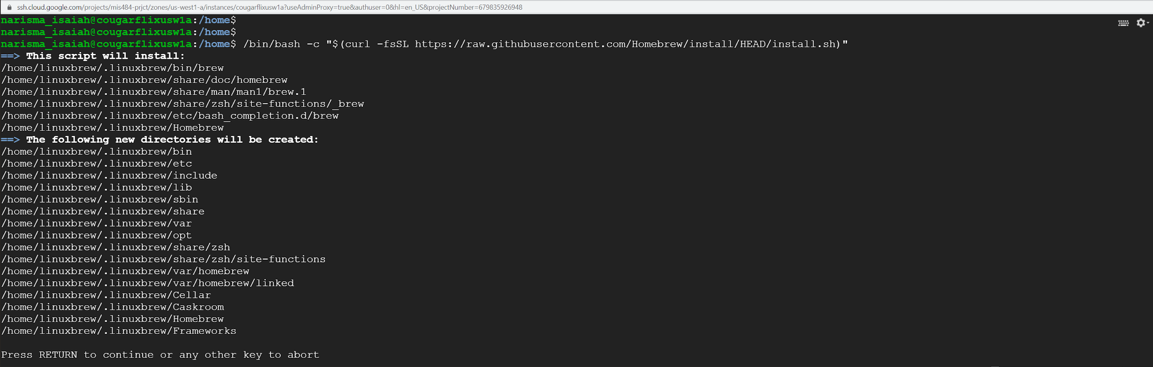

Installing Homebrew to install terraform

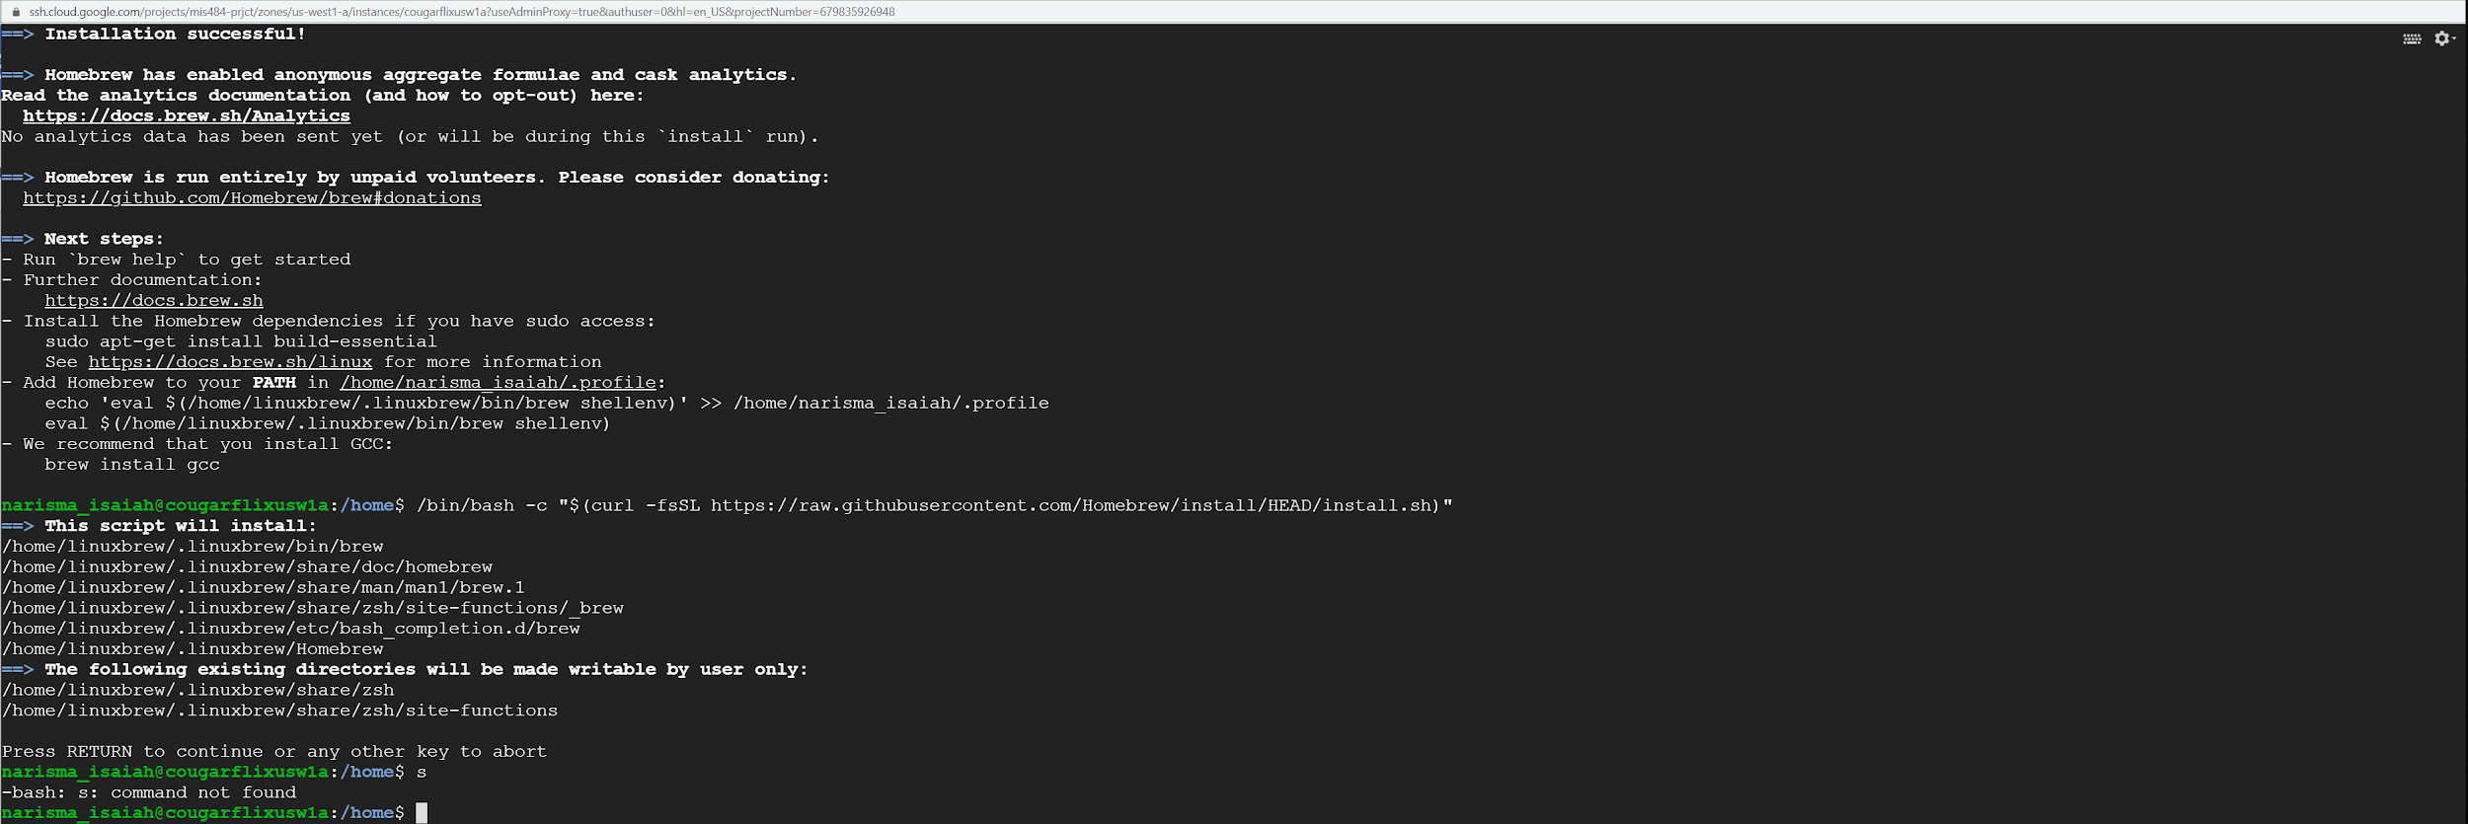

Homebrew Installed

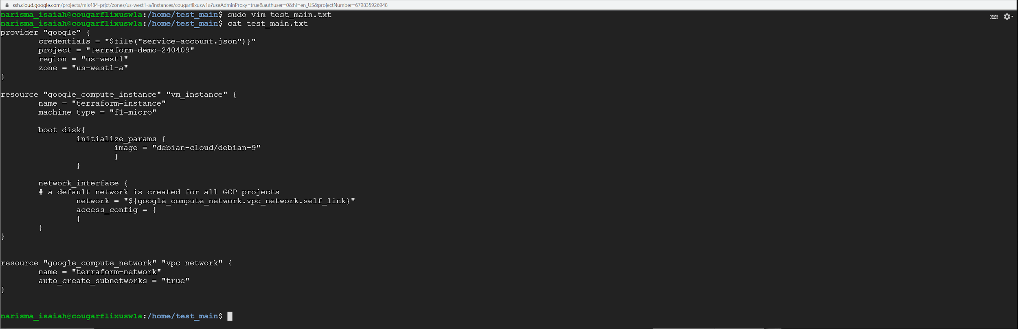

Preparing the script to create an instance in GCP

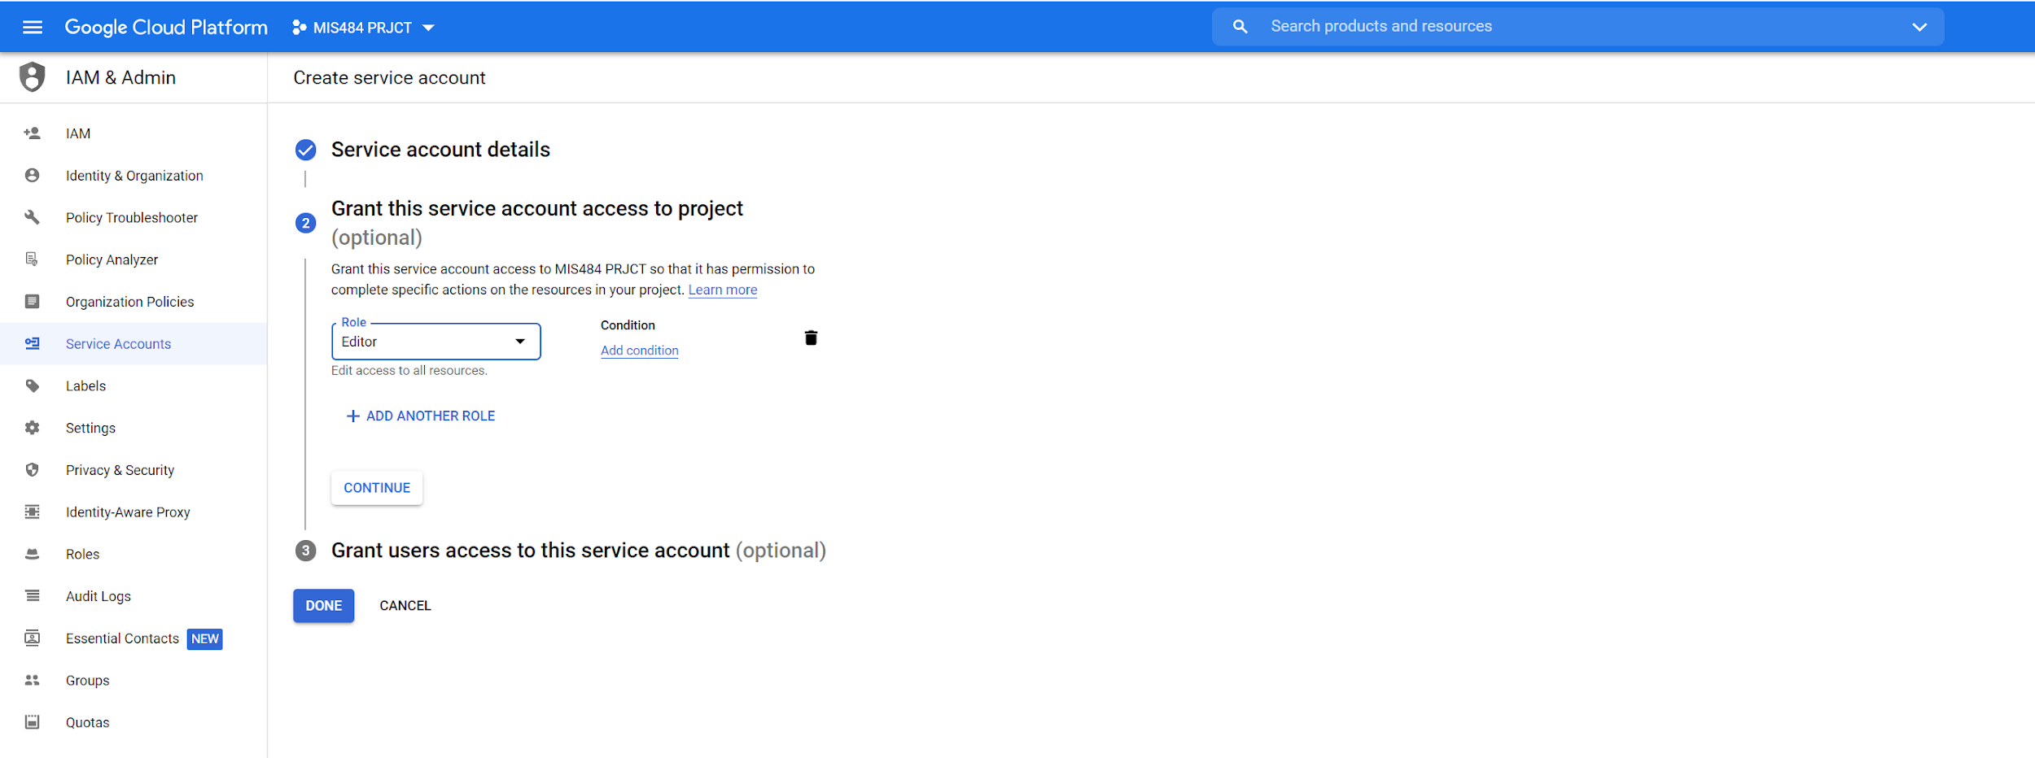

Creating a service account for our terraform.

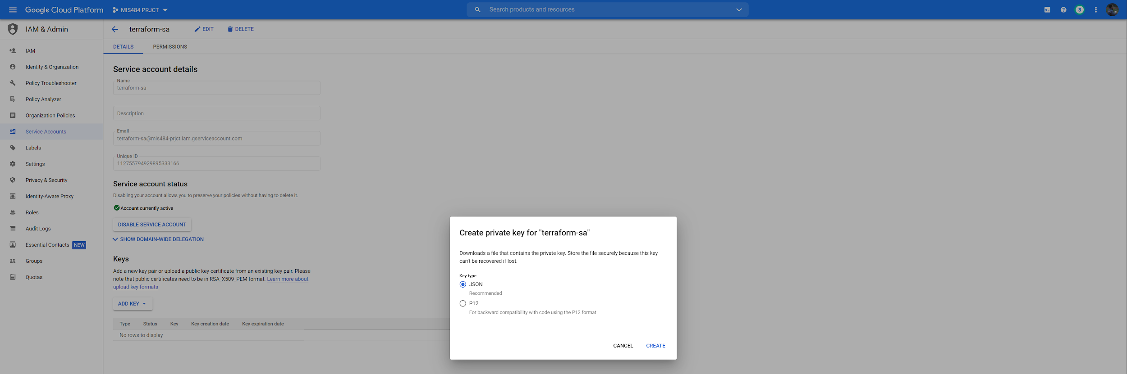

Creating an access key for our service account

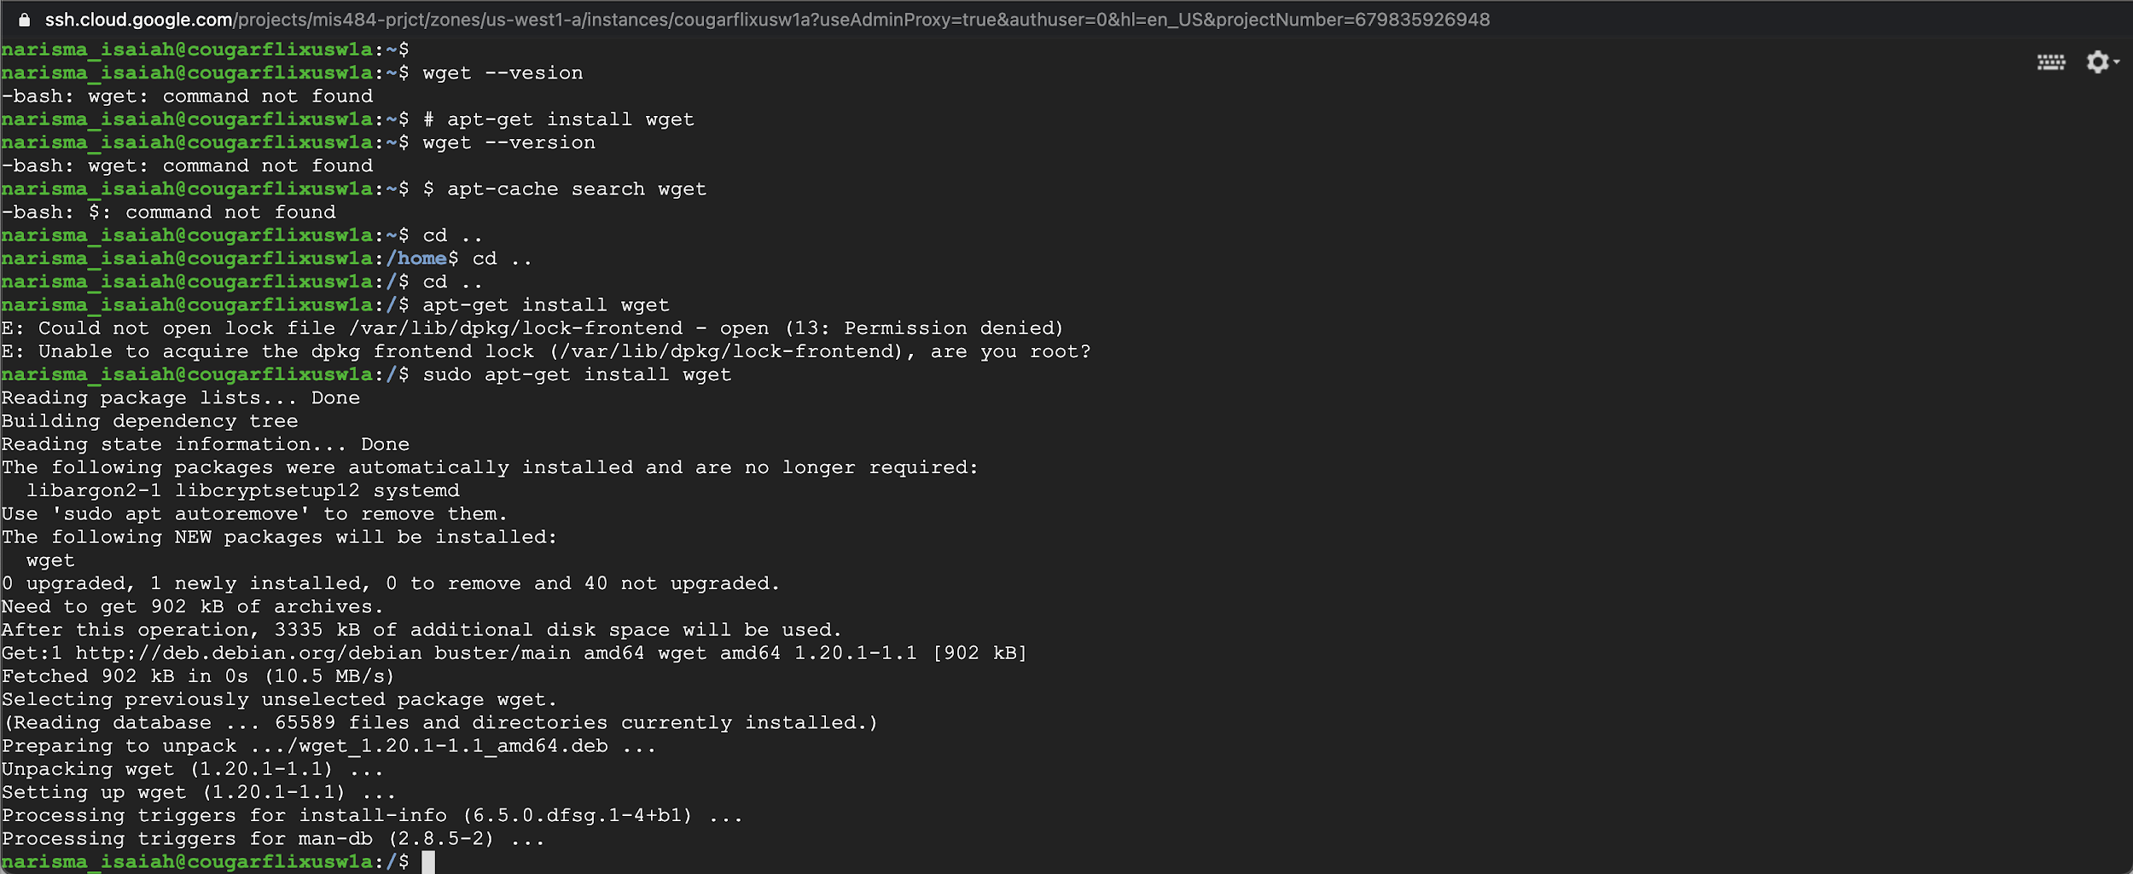

Installing wget

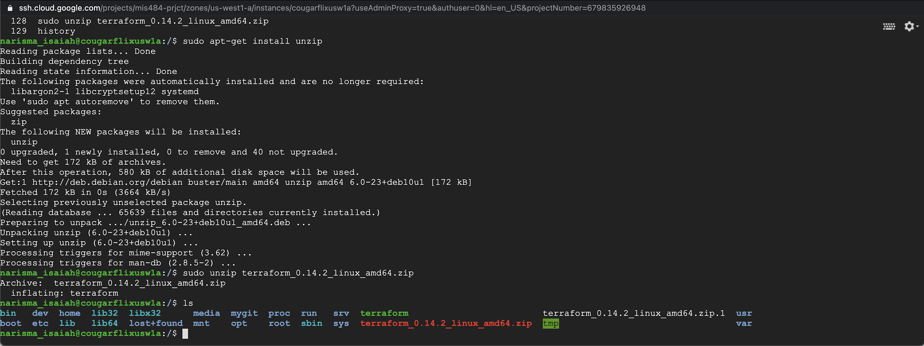

Have to install a few commands to get it to work, I had to install `wget` and install `unzip` commands to make this work. Such a hassle

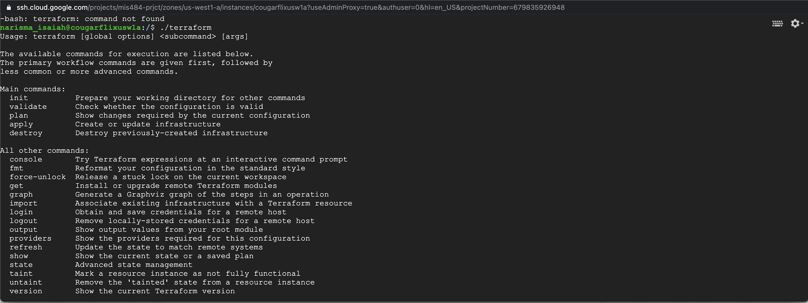

Terraform is installed; however, the command is not linked to `terraform` as it only works when we enter `./terraform` so we need to fix the path.

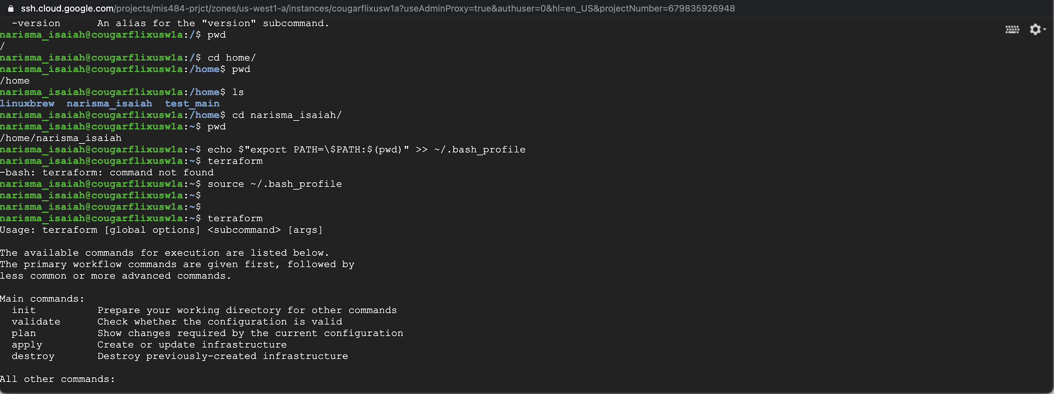

We need to change the pathing to make the command `terraform` work.

This is because `terraform` is an executable file meaning by default it can only be accessed by `./terraform’ command or if you include your current directory. This is how you fix it above.

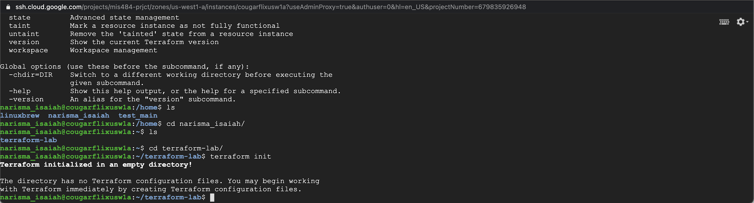

We are ready to begin creating our terraform files

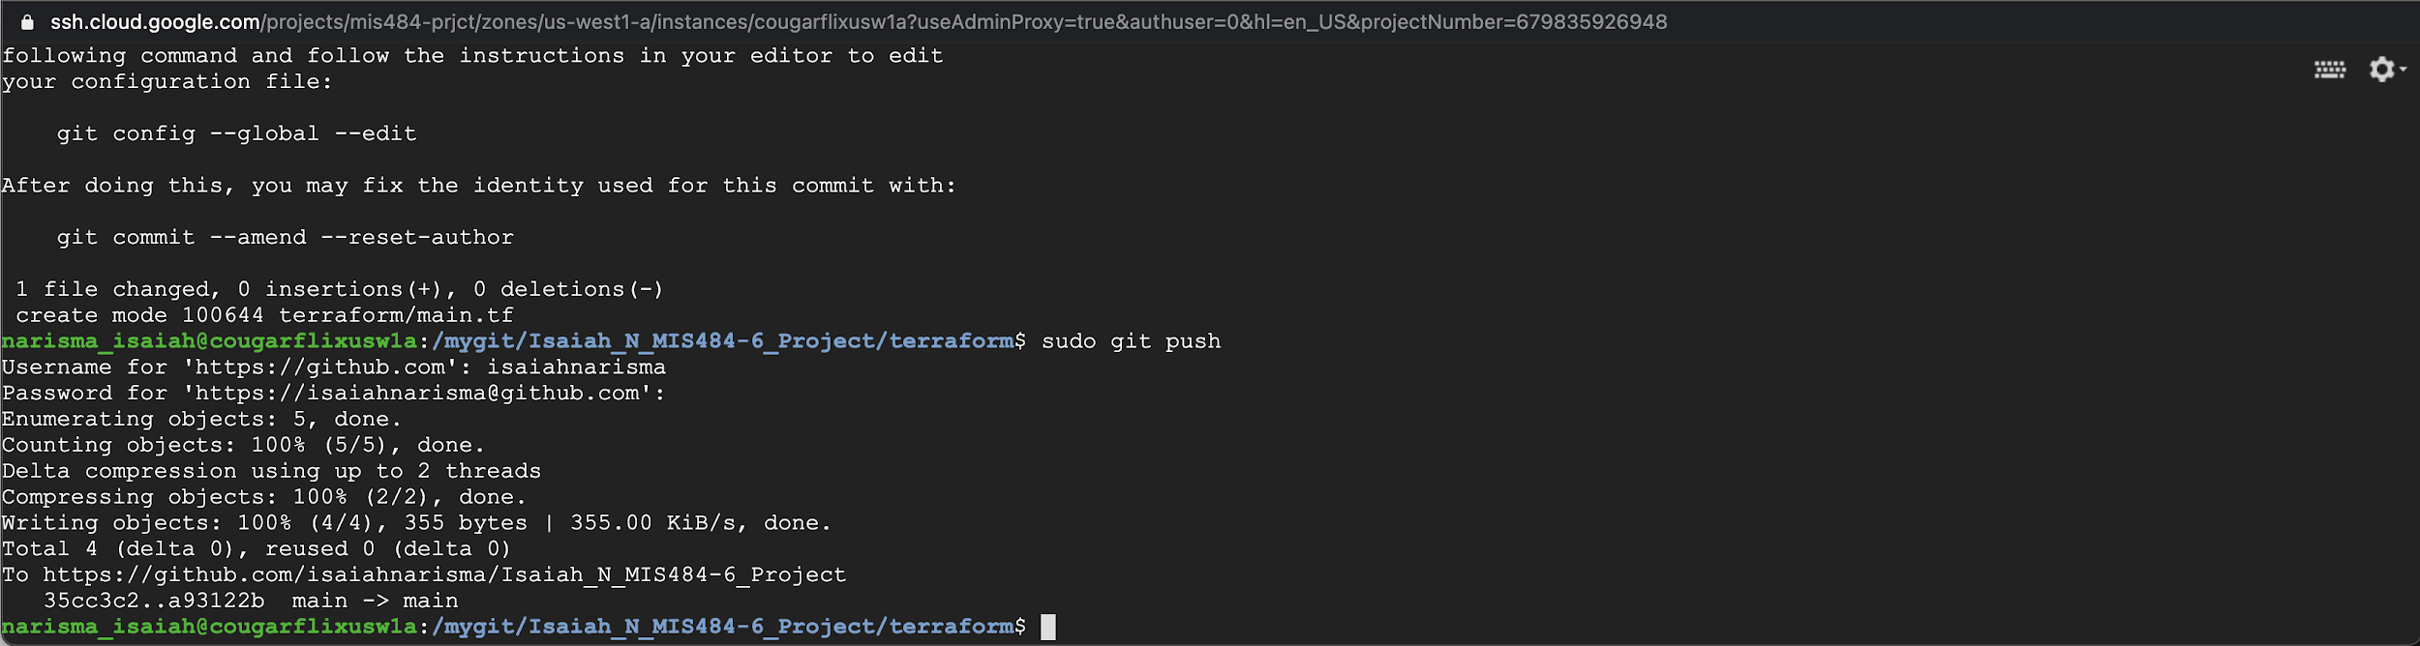

Pushed our git onto github

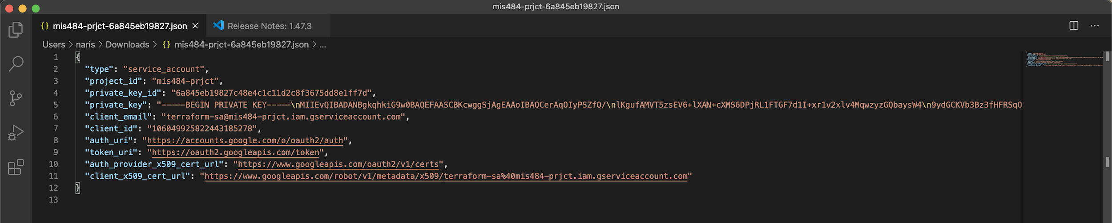

My GCP Service Account key

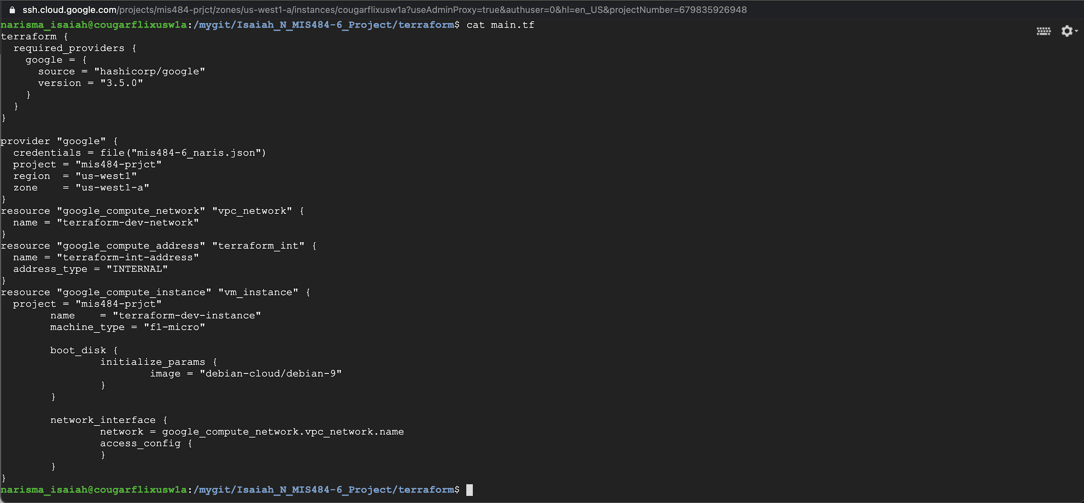

Our main.tf file with substituted code

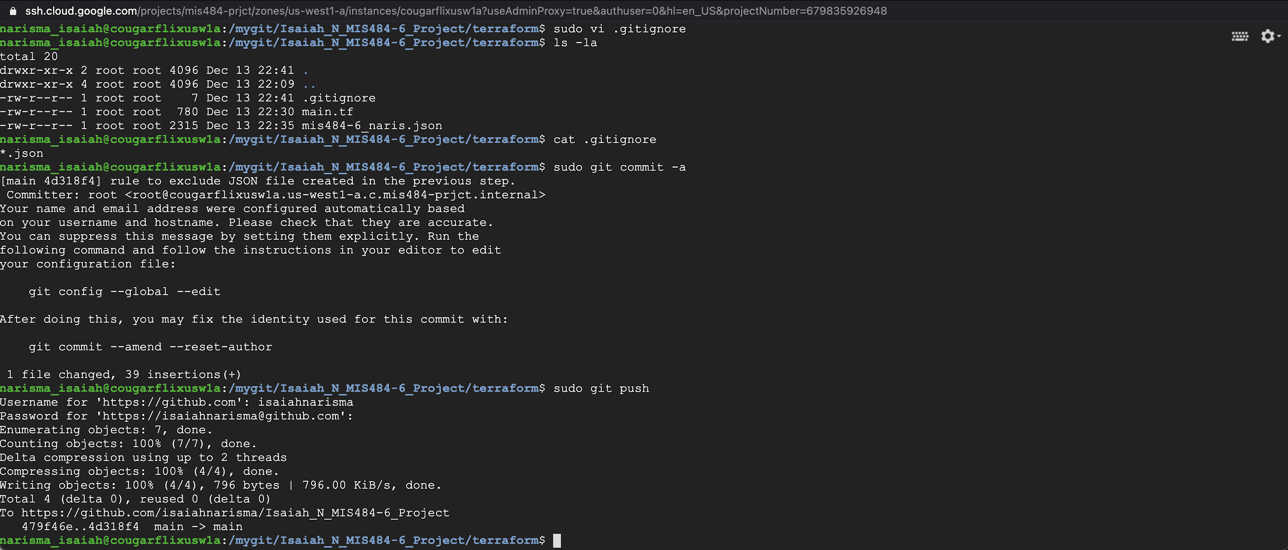

.gitignore file created and *.json was attached.

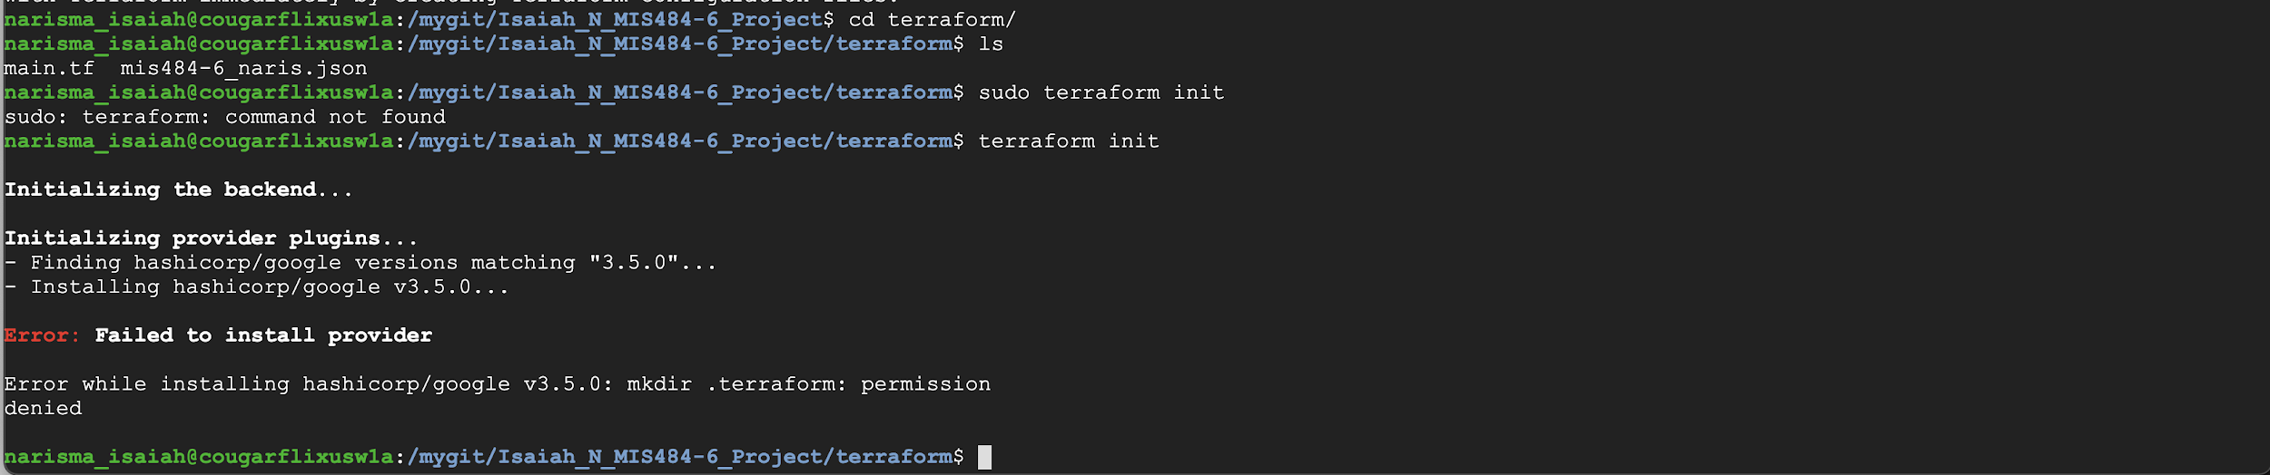

Terraform init problem?

So I reached out to some classmates and Michelle told me that I should move my terraform inside my terraform directory in mygit.

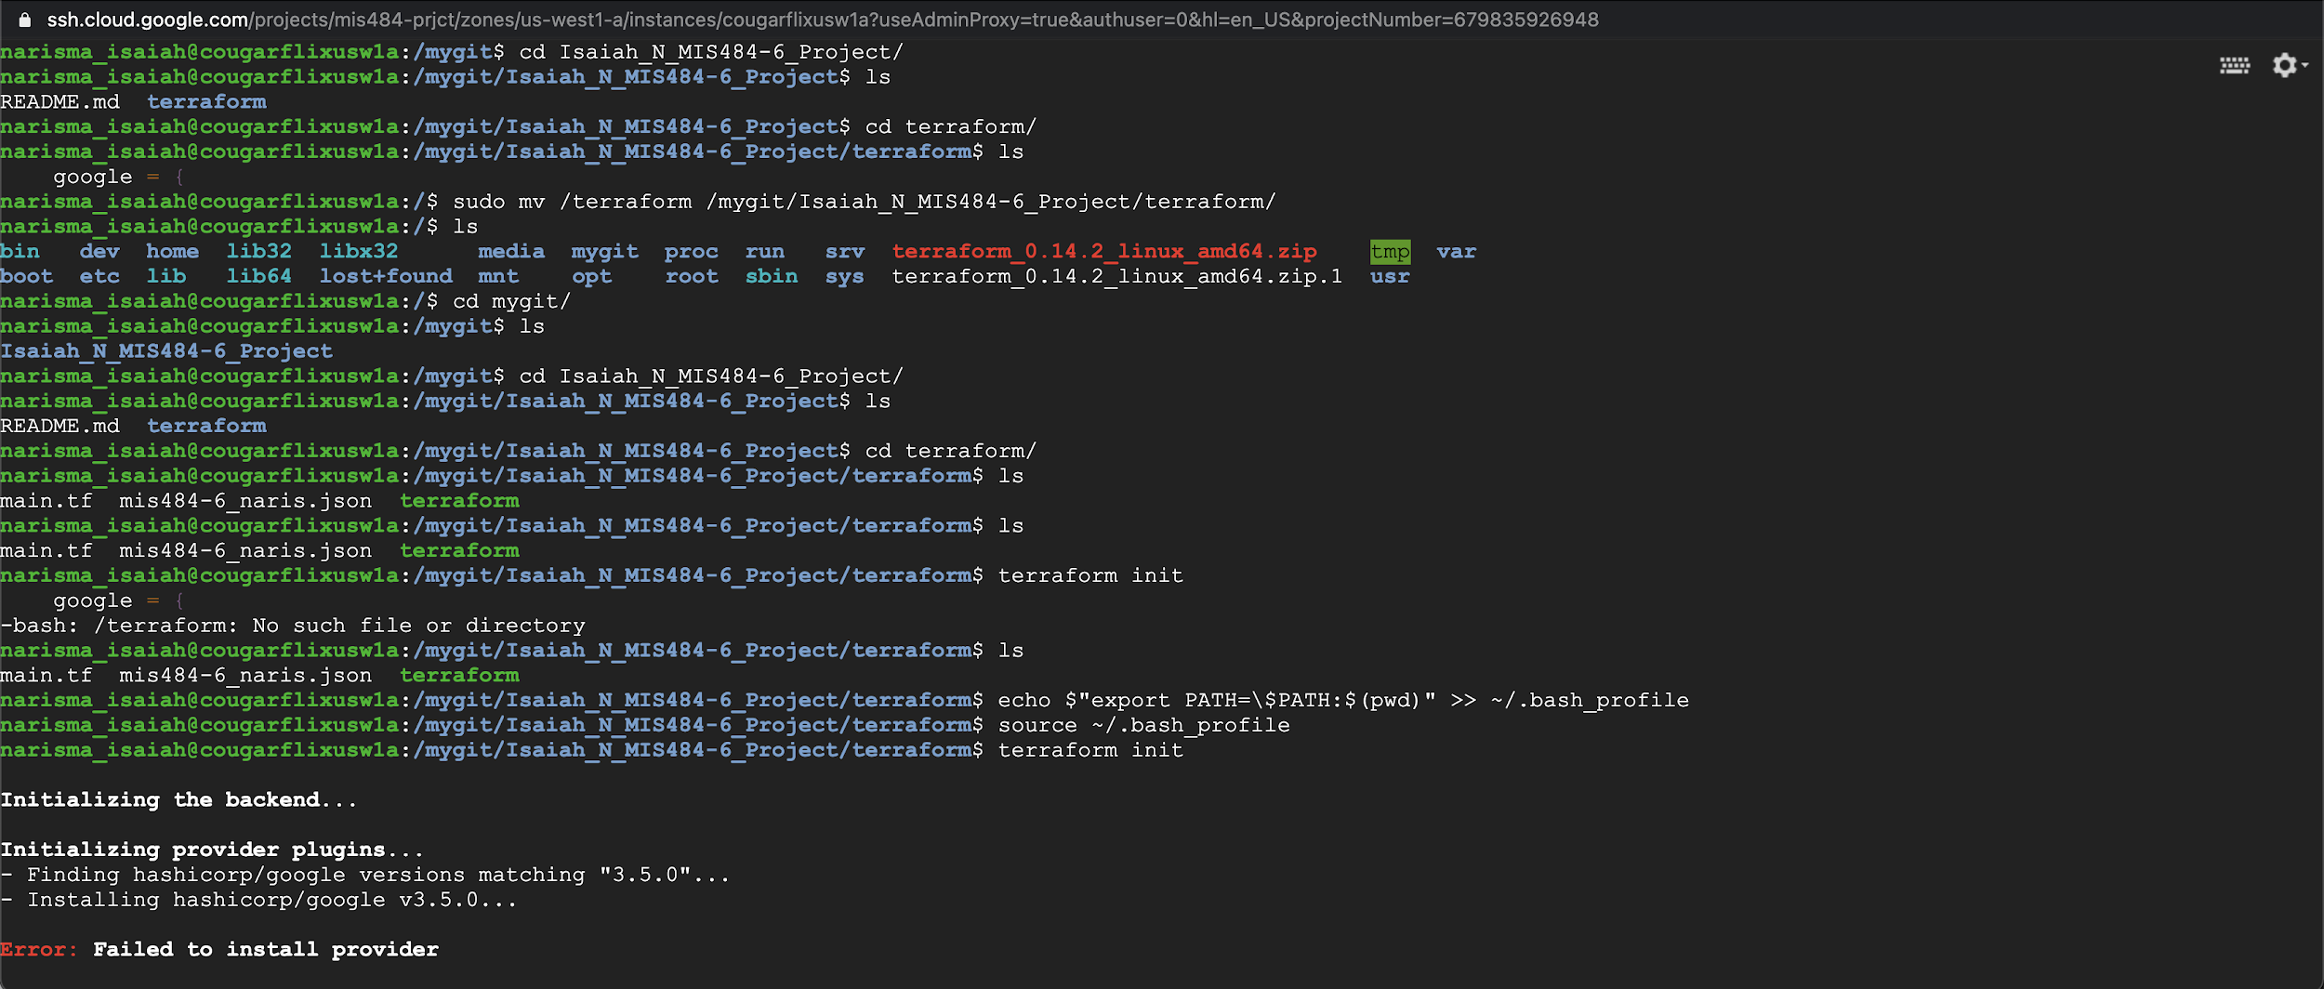

Still the same problem.

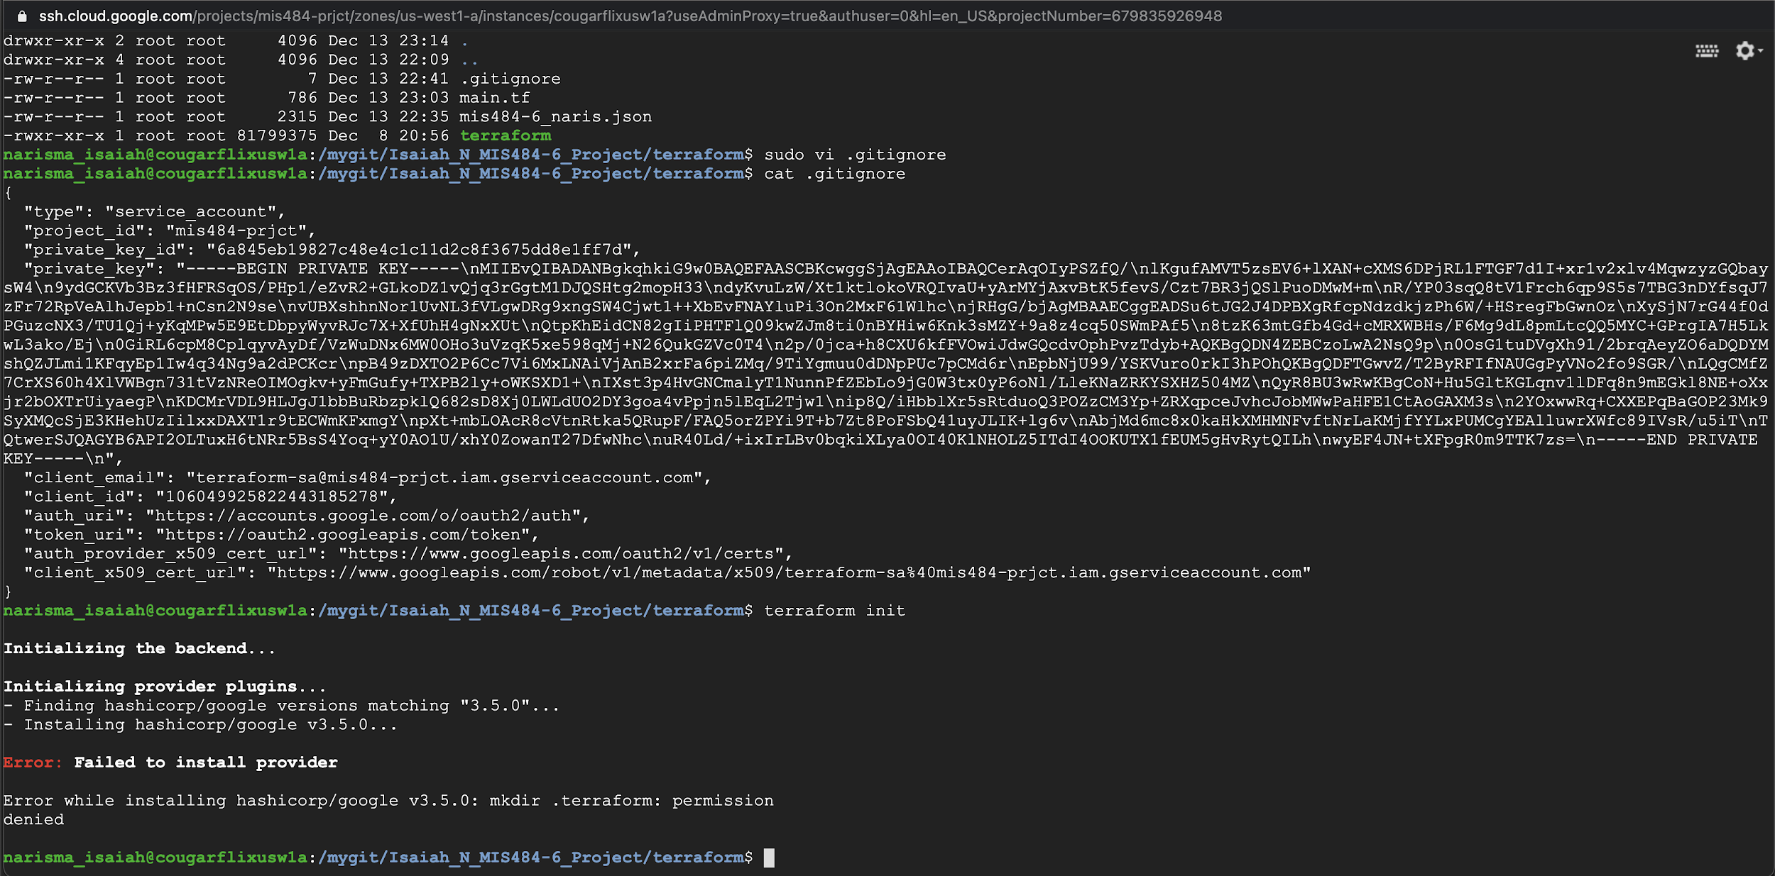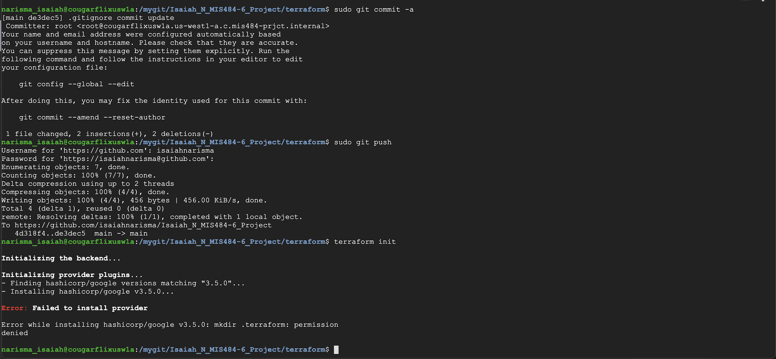

Allen recommended that I copy all of my .json file code into the .gitignore file and commit and rerun ... still doesn’t work

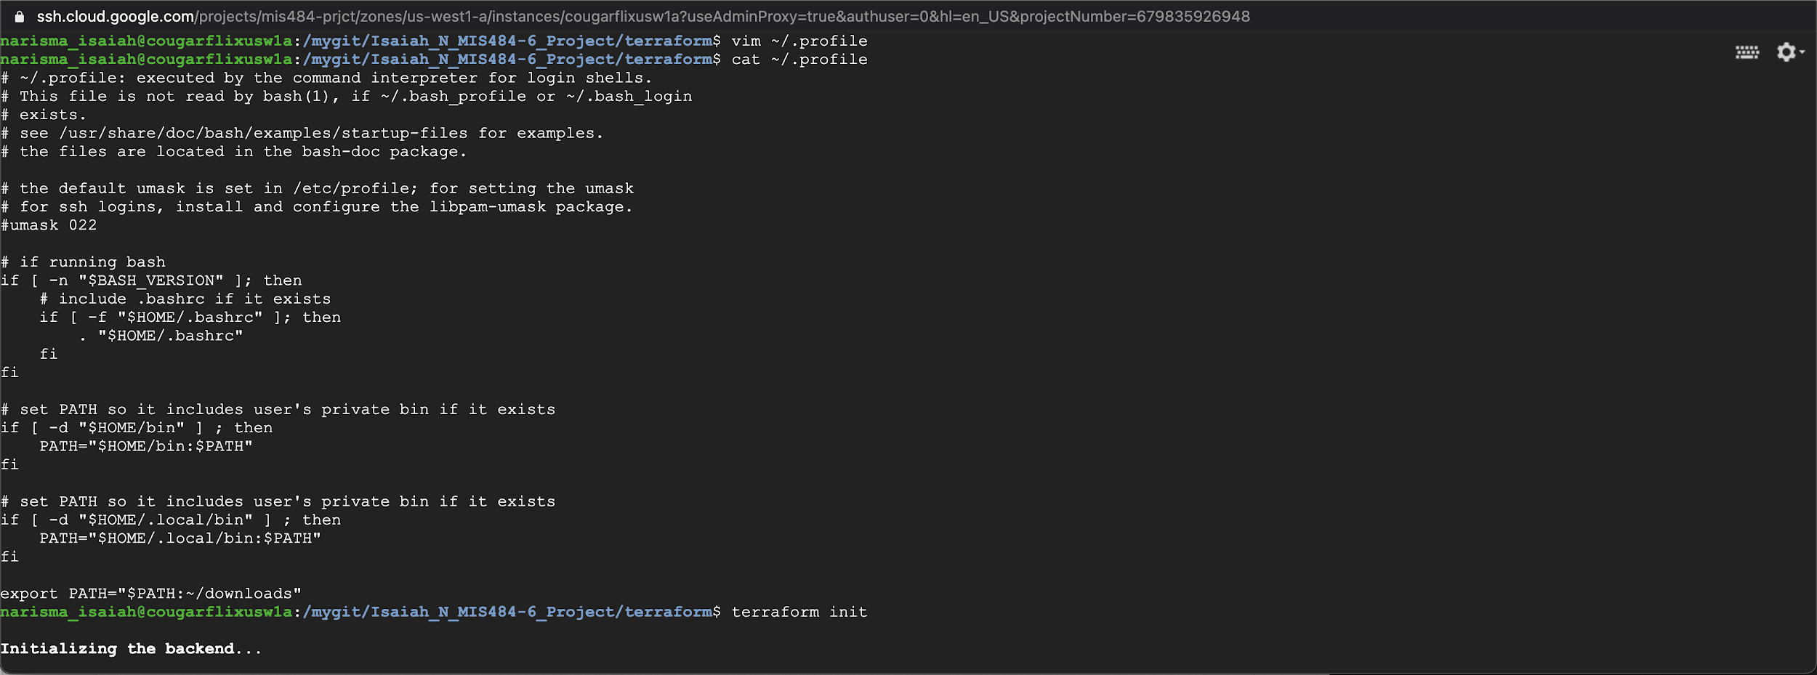

Allen also suggested that I make some edits to my ~/.profile to try to fix it, no luck...

WORKAROUND:

So the eventual workaround that we had to come up with after hours of troubleshooting and researching; was that Allen would share his screen and I would essentially use his instance to provision an instance in my GCP using my resources from my GitHub Repo.

Allen was kind enough to stick with me later that night and help me out with this. We were screen-sharing his screen on Google hangouts while I told him what to do, and the first thing that we did was connect my GitHub repo to his instance, using the same procedures as if I would connect to an instance. From there, we has able to perform a `git clone` and take all of my resources.

Allen and I proceeded to check all of our /.profiles and make sure the pathing was correct. We also moved my `terraform` into my `terraform` directory within my repo directory and made it work.

Moment of truth, we executed `terraform init` and success! We were able to execute a terraform init where as with my instance for whatever reason we could not.

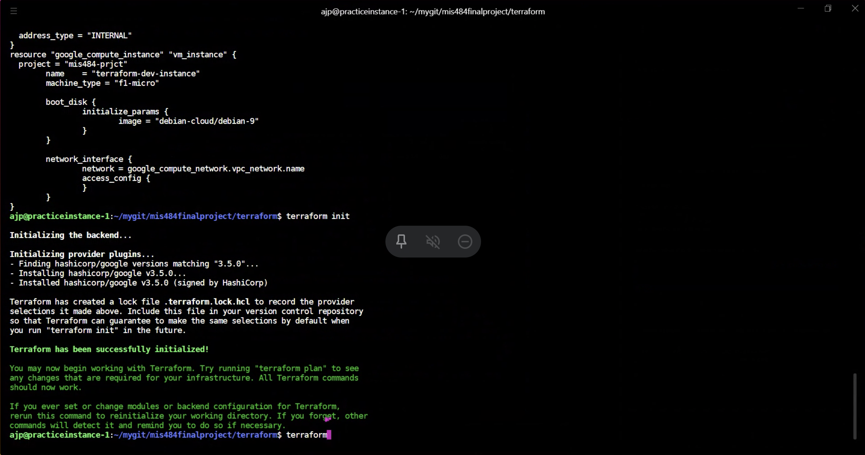

`terraform init` execution works on his instance. Success!

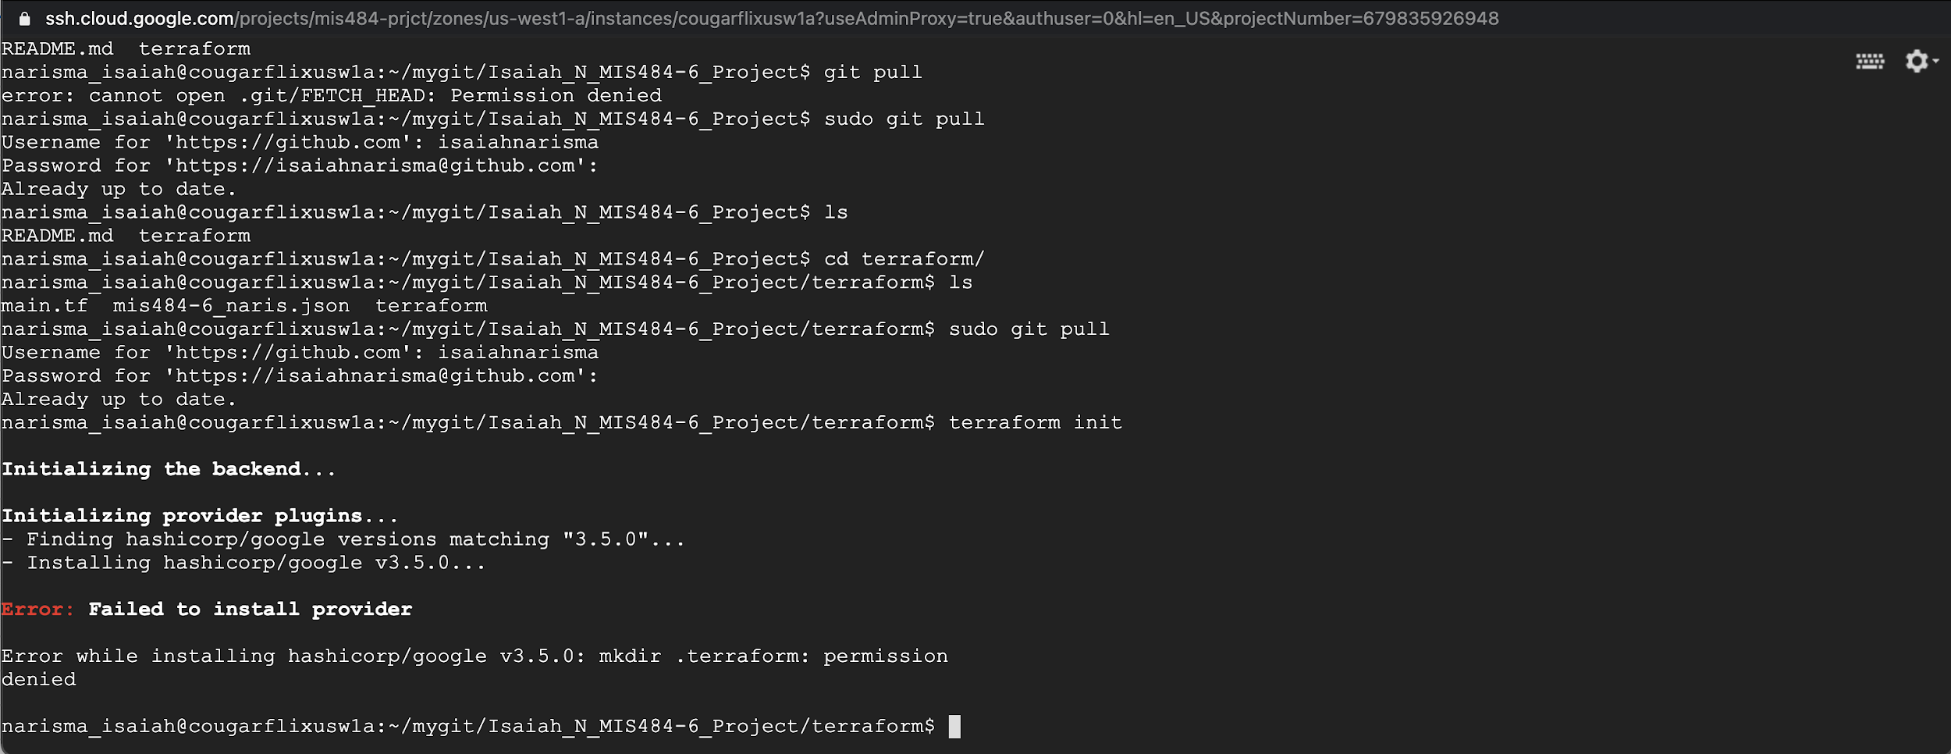

However, if I try to do it on my instance after I git pulled, it still doesn’t work.

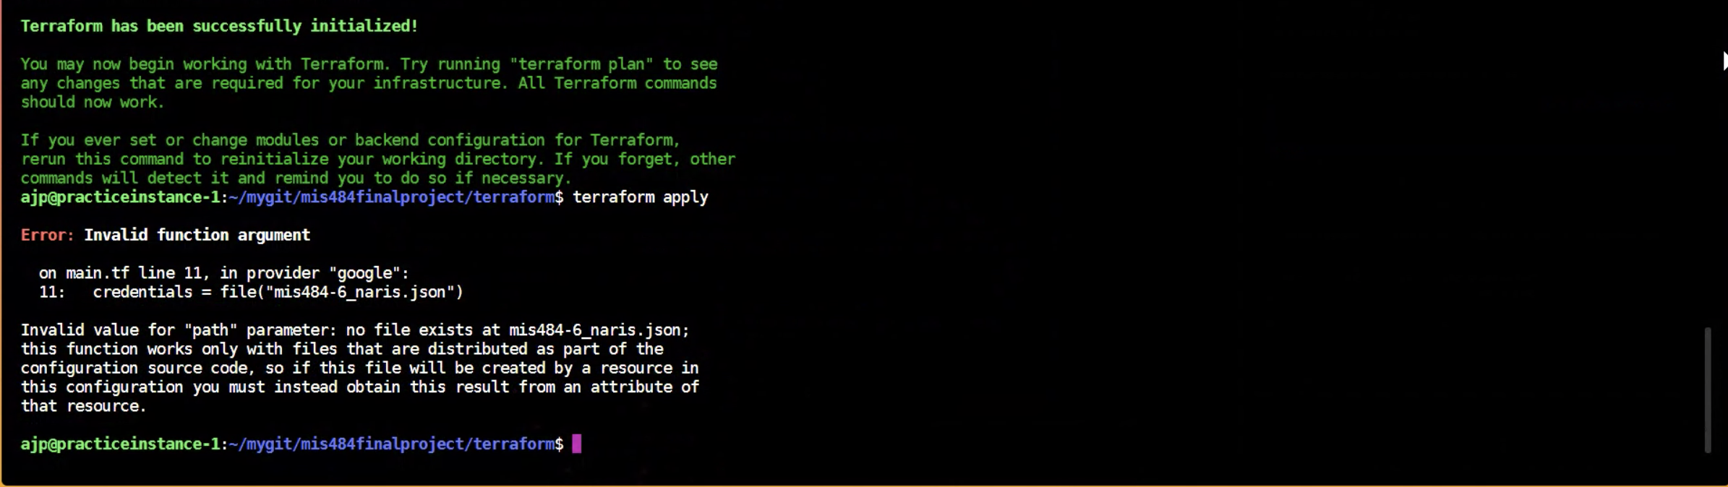

However, we are not out of trouble just yet. We realized that when we would perform `terraform apply` we would get this error.

In order to fix this, we had to make changes to my .json file and recheck the pathing again, and that seemed to work.

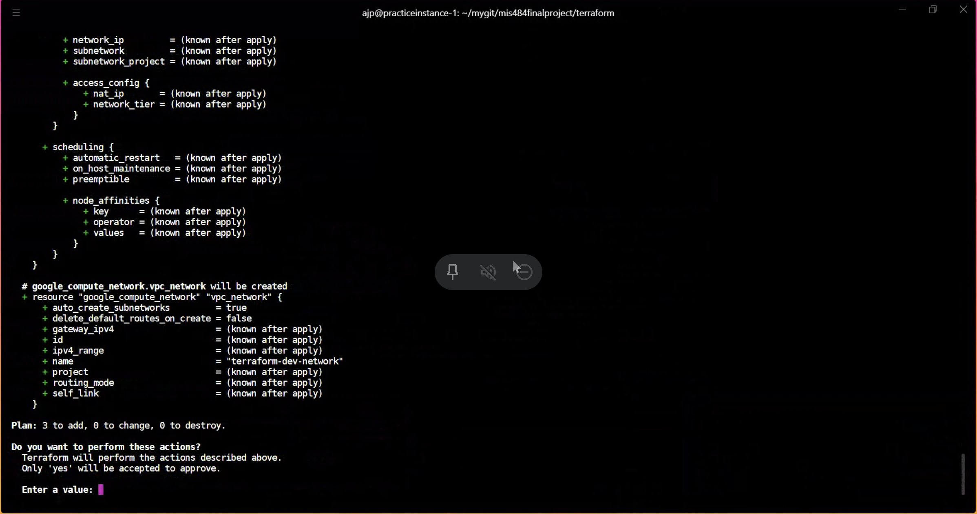

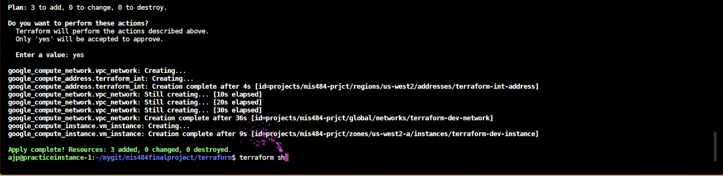

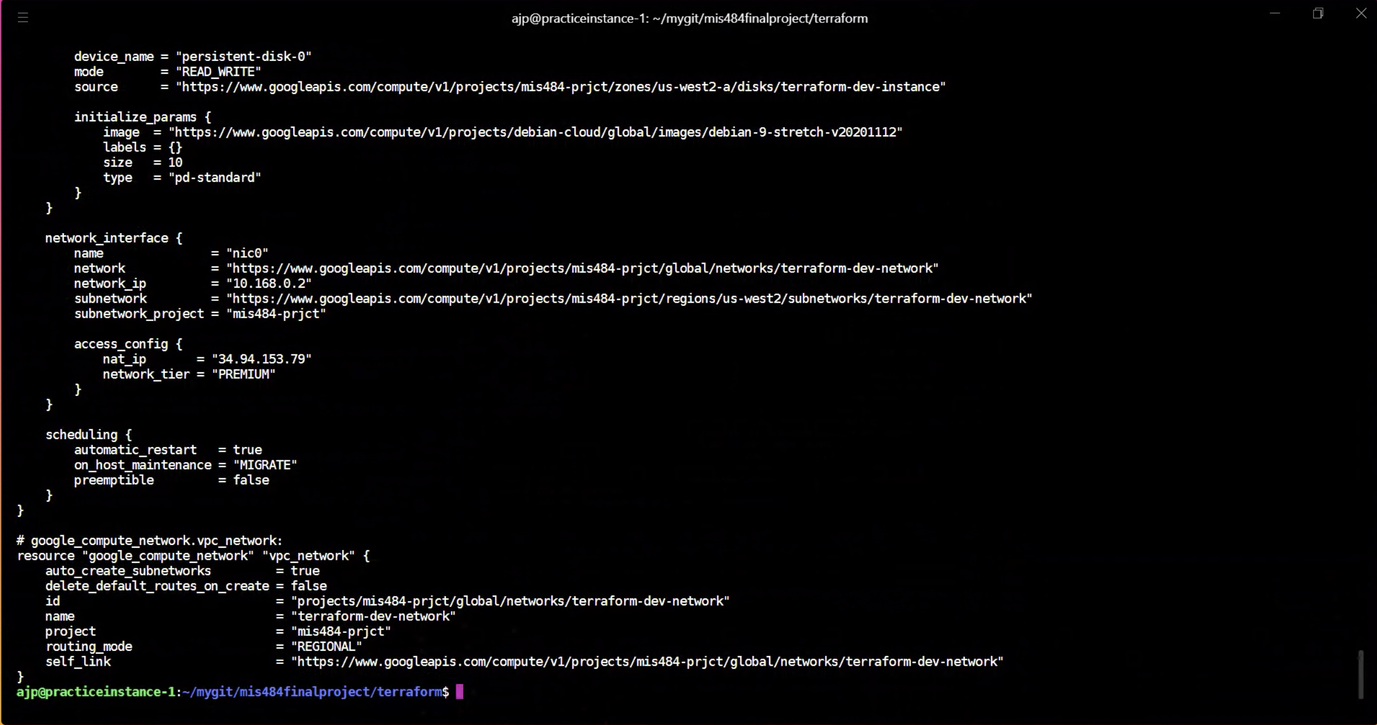

`terraform show` to show the instance created programmatically.

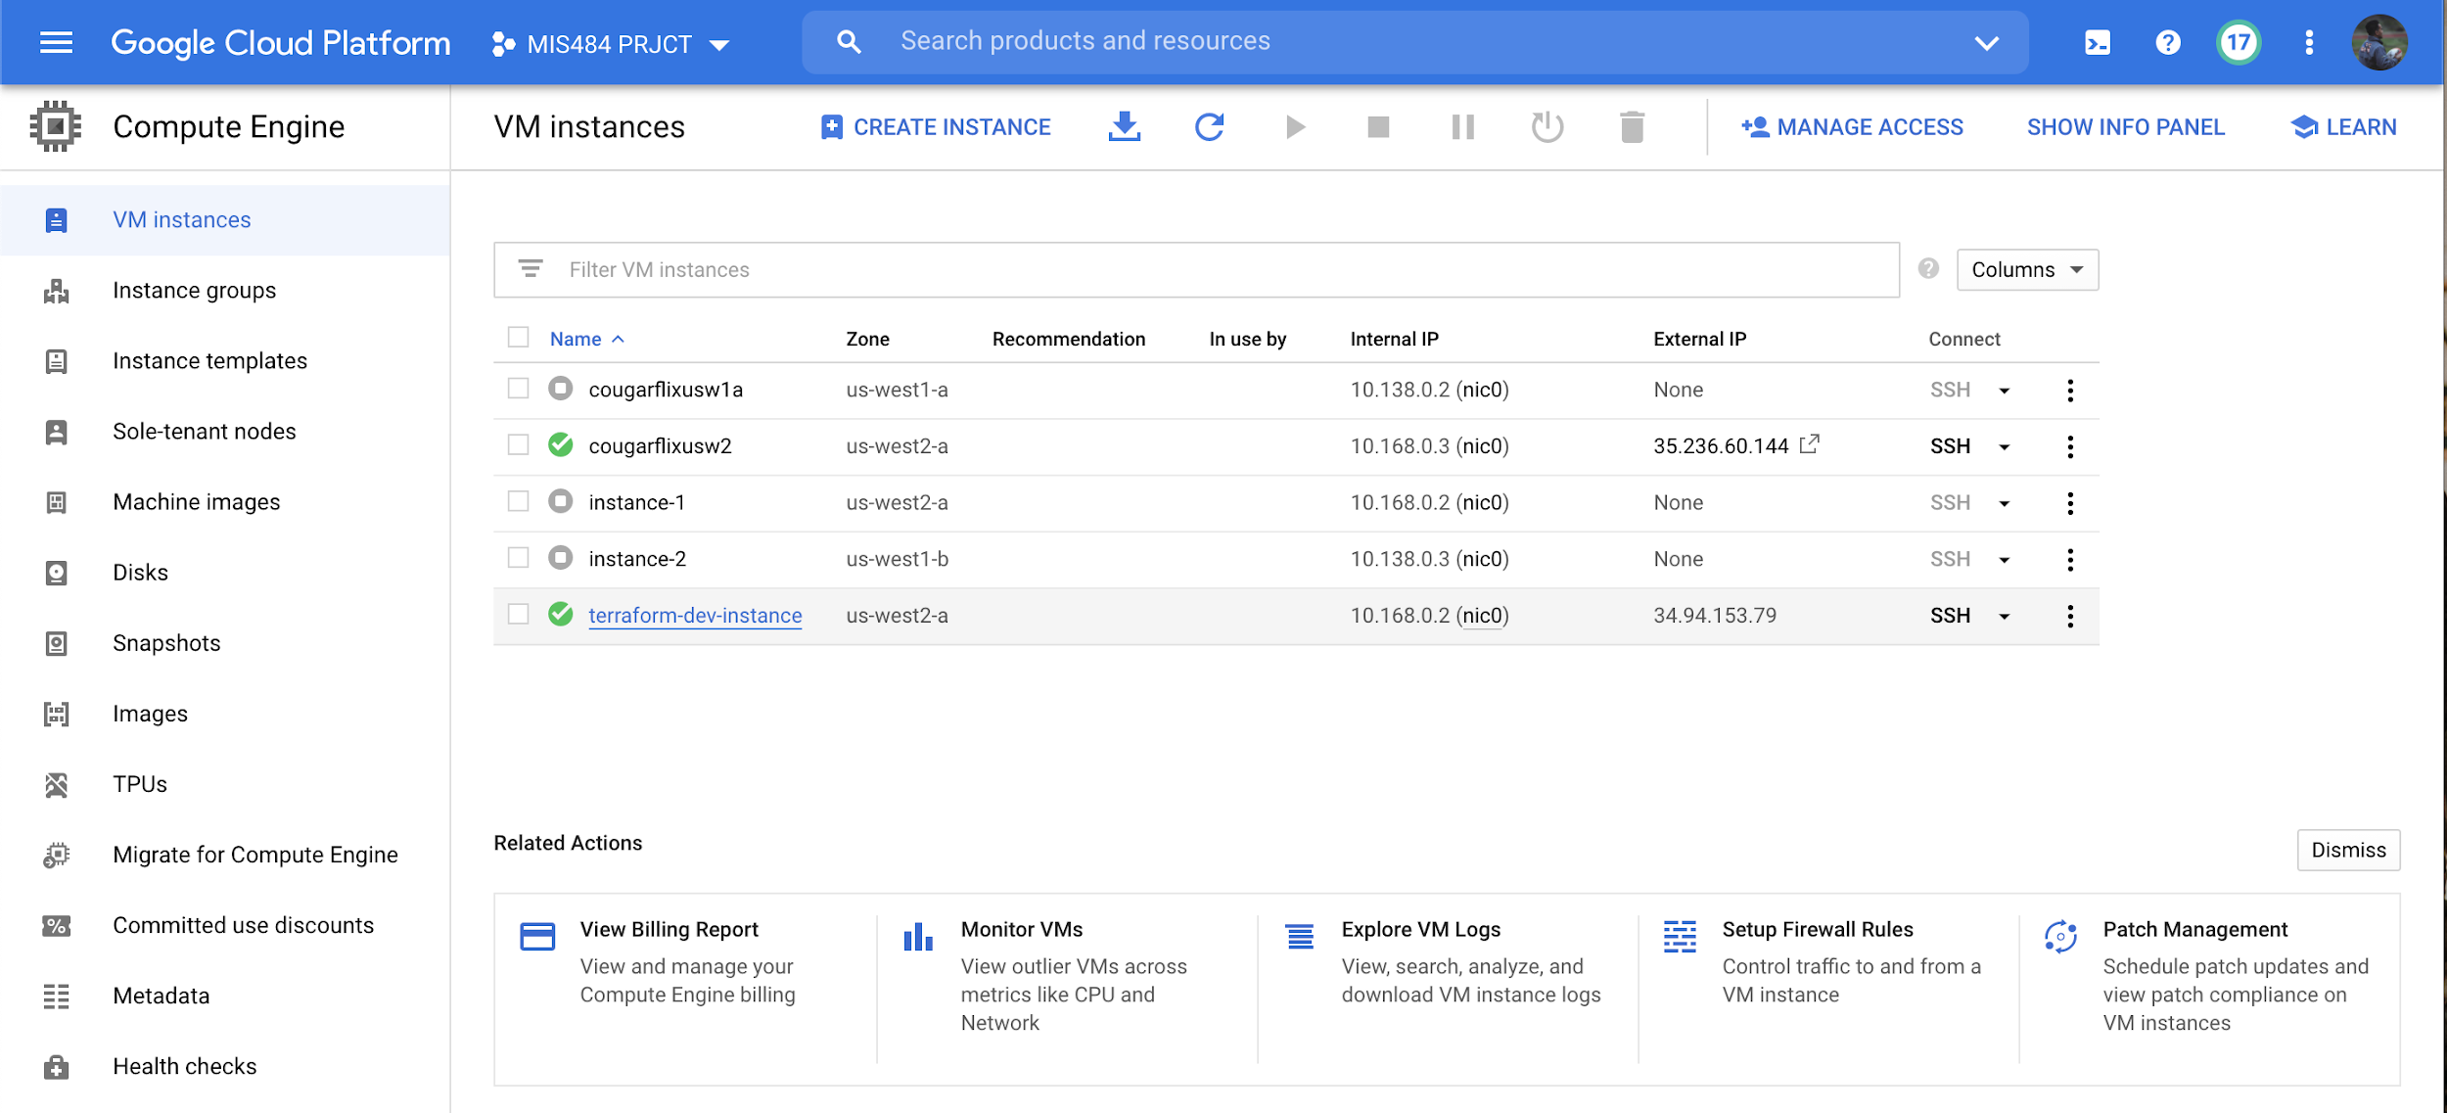

Final instance `terraform-dev-instance` created in my VM instances.